A TOTALLY INTEGRATED MUNITONS ENTERPRISE (TIME)

Abstract. The Totally Integrated Munitions Enterprise program is a U.S. Army program, which is focused on addressing several key issues the Army now faces with respect to the design, development and production of munitions. The approach being taken by the Army is to implement a systems engineering approach across the entire munitions manufacturing enterprise enabled by Internet/Web based of the shelf tools along with a limited set of newly developed tools. A systems engineering approach is being used to develop and validate the key elements of the TIME program prior to deployment in both government and commercial munitions manufacturing environments.

Introduction. The primary issues in the U.S. Army’s munitions manufacturing for the 21st century (figure 1) center on the ability to quickly establish scale-up of new processes, shorten the time from conceptual development to volume production while reducing the cost of complex smart munitions, and to establish replenishment capabilities of the DoD arsenal in times of national emergency. Agile and Flexible manufacturing processes and systematic technology transfer methodologies need to be developed for the efficient and sustainable production of current and future munitions in concert with both future DoD and Commercial Industry capabilities.
TIME will provide a collaborative environment that integrates Engineering, Production and Business Tools throughout the products life cycle. Communication elements will be capable of carrying data to and from different levels of the virtual Enterprise including from the highest levels in an organization or geographically separated sites to the shop floor. TIME will include open architecture software; model based controls and open modular architecture controls (OMAC); and will provide linkage with commercial enterprise tools to enable Internet/Web based electronic data linkage/transfer. A range of munitions manufacturing will be addressed including but not limited to metal parts, electronics (with emphasis on state-of-the-art high performance and/or miniaturized components), mechanical assemblies, composites and energetics.

Objective. The objective of the TIME program is to establish the manufacturing methodology that enables cost effective, agile, rapidly reconfigurable, distributed enterprise and control technologies for munitions manufacture. This includes establishing seamless interaction among discrete and distributed design, scientific models, scale-up production and administration units over a high speed communication network, and a backbone environment and operating system for real time data acquisition and remote control.
Approach. The Louisiana Center for Manufacturing Sciences (LCMS) was

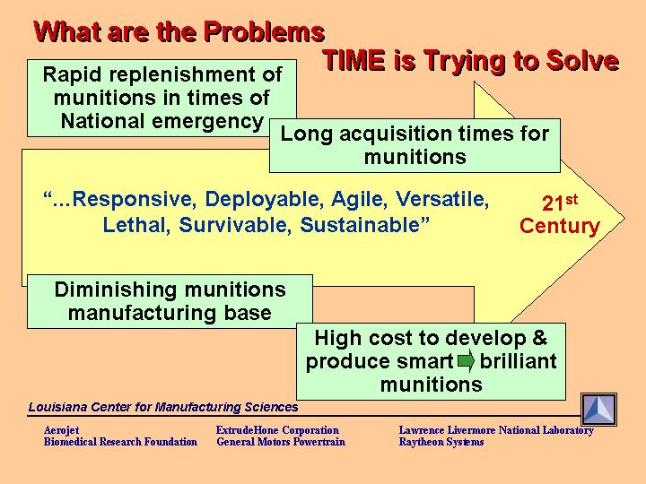

Figure 1

awarded contracts from the U.S. Army to perform the development activities required for the TIME program. The LCMS consortium consists of industry giants: General Motors Powertrain, Raytheon and Aerojet. It also includes the Biomedical Research Foundation of Northwest Louisiana, ExtrudeHone, and the highly regarded University of California Lawrence Livermore National Laboratory.
LCMS, using a systems engineering approach, is developing the TIME architecture for munitions enterprise systems and providing critical enabling technologies required for supporting the design, development, processing, and manufacturing of a variety of materials and products associated with the manufacture of munitions, including energetics, metals, composites, and electronics.
TIME is a multi-faceted program with several concurrent tasks under the headings of:
- Enterprise Architecture. The enterprise can include the current set of government munitions manufacturing organizations or in times of national emergencies, can be extended to include commercial suppliers.
- Activities focused on the identification, evaluation, testing and validation of collaborative tools that can be integrated together to perform all of the functions associated integrated product realization process, the systems engineering process used to design develop and manufacture munitions. This includes the toolsets for both Integrated Product Realization (including mechanical piece part tools and the Open Modular Architecture Controller (OMAC)) and Enterprise Systems (networking and general purpose collaborative tools).
- Linkage with other Tools addressing key munitions technology/processing areas including the Automated Concurrent Engineering System (ACES) being developed outside of the TIME program by the Stevens Institute.
- Concept validation demonstrations provide confidence that the elements of the TIME program meet requirements. Demonstrations have validated the capabilities to perform real time concurrent engineering activities across diverse geographically disperse organizations in a highly effective manner. Munitions design and manufacturing teams (the U.S. Army’s Armament Research, Engineering and Development Command (ARDEC) at Picatinny Arsenal. have collaborated real time on the essential elements of a munitions design and manufacturability. Design and manufacturing process information has been modified real time between Primex Technologies and their simulated extended enterprise partner General Motors Powertrain (figure 2) using the TIME collaborative tools. General Motors Powertrain the manufactured the munitions parts to the exact specifications required by the U.S. Army.
The open architecture controller being developed for the Army by LCMS will enable communications of design and process information directly to the manufacturing machine equipment. The open architecture modular structure will enable the development of many third party applications, which will enhance

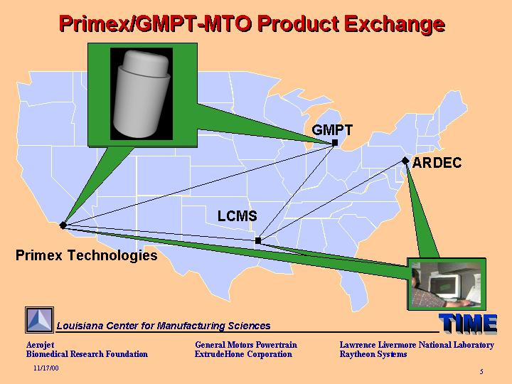

Figure 2

the effectiveness of the machine equipment providing agility to rapidly

reconfigure inexpensively manufacturing machine equipment. Another significant element of the OMAC is the ability to control multiple elements of a manufacturing process based on numeric physics based models. This will enable model-based control of explosive processes. Processes used in the production of energetic materials for munitions.

LCMS will be initiating the incorporation of Life Cycle Management tools and approaches (including supply chain/logistics) into the TIME program. Further demonstrations of TIME in an Enterprise environment will be accomplished at various sites, including support to ARDEC’s Integrated Data Environment (IDE) efforts.
The TIME network will ultimately allow secure, interactive, multimedia communication between nodes, thus enabling a concurrent systems engineering environment.
The multi-year, Manufacturing Technology (MANTECH) TIME program is ongoing to address the needs of the future production base with initial emphasis on Virtual Factories and affordable smart munitions
TIME will facilitate acceleration of the acquisition cycle by linking or coupling life cycle stages, including process models, R&D initiative, prototyping, shorten times leading to scale-up/production, and fielding/logistics. While addressing the peacetime procurement requirements, the needs for rapid buildups for national emergencies or replenishment requirements will be facilitated by TIME’s capture of the manufacturing processes and communication of these to remote sites or new contractors for “first part correct’ capabilities. Accordingly, Virtual-manufacturing capabilities would reduce the reliance and expense of standby or laid-away production base.

TIME is a “Systems Approach” which addresses manufacturing as a system within the overall virtual Enterprise, which also includes programmatic and management requirements and information such as Resources, Supply Chain and other required information. Rather then working in a serial fashion, TIME enables concurrency and IPPD to move the programs to controlled, integrated total product realization.
TIME can be looked at in two integrated pieces; the overall architecture connecting the requirements and tools of the enterprise and the Model Based Control systems which enable the use of Open Modular Architecture Controllers (OMAC). The latter is a major requirement of both Industry and the Government as the needs for manufacturing virtual enterprises. As these enterprises, containing equipment from hundreds of different manufactures, are spread around the country or the globe, immense volumes of product information must be transferred between the various facilities and machines. While designs are conducted at one site, machining or processing centers are often widely scattered. Today’s digital communications standards and products are necessary to reliably transfer information across national or global networks which leads to the use of standard data throughout the entire process chain in the manufacturing enterprise.

TIME’s MANTECH efforts address a wide range of items of interest to the PEO, including metal part fabrication, electronics/GPS, and energetic material processing. TIME is also being used to integrate ARDEC’s IDE, is under evaluation by PM Crusader and, would directly benefit the FCS program through its early incorporation into the design down select stages.

